MINI PROJECT REPORT ON
“LIBRARY MANAGEMENT SYSTEM”

Submitted in the partial fulfilment for the award of a degree of Bachelor of Computer Application



UTTARANCHAL UNIVERSITY
Bachelor of Computer Application
School of Computing Sciences
Session (2025-2028)

Under the supervision of: Submitted By:
Ms. Vaibhavi Kaushik Ayush Verma
Assistant Professor BCA I-C

ACKNOWLEDGEMENT

The most awaited moment of any endeavour is successful completion, but nothing can be done successfully if done alone. Success is the outcome of contribution and consistent help of various persons and I thank those ones who helped me in successful completion of this project.
Primarily, I would like to thank Prof. (Dr) Sonal Sharma, Director of USCS for providing a healthy and encouraging environment to study.
Secondly, I would like to thank Prof. (Dr) Sameer Dev Sharma, HOD USCS
I express my thanks to Ms. Vaibhavi kaushik, Project Mentor, and Assistant Professor USCS. She has been generous enough to provide me an opportunity and accepting my candidature for the most valuable guidance and affordable treatment given to us at every stage to boost my morale.

AYUSH VERMA
BCA-I-C

DECLARATION

I hereby declare that the project report titled “LIBRARY MANAGEMENT SYSTEM” is submitted by DEEPAK SINGH RAWAT to Uttaranchal School of Computing Sciences. The project was done under the guidance of Ms. VAIBHAVI KAUSHIK Assistant Professor, and USCS. I further declare that the work reported in this project has not been submitted, either in part or in full, for the award of any other degree or diploma this University or any other University or Institute.

Ayush Verma
BCA-I-C

CERTIFICATE OF ORIGINALITY

This is to certify that the project entitled “LIBRARY MANAGEMENT SYSTEM” by Ayush Verma has been submitted in the partial fulfilment of the requirements for the award of the degree of Bachelor of Computer application from Uttaranchal University, Dehradun. The results embodied in this project have not been submitted to any other University or Institution for the record of any degree.

Under the guidance of:
Ms. Vaibhavi Kaushik
(Assistant Prof)
(USCS)

TABLE OF CONTENT
S.NO | CONTNET | PAGE NO.
 | ACKNOWLEDGEMENT
 | DECLARATION
 | CERTIFICATE OF ORIGINALITY
 | TABLE OF CONTENT
1. | INTRODUCTION | 1
2. | OBJECTIVES | 2
3. | HARDWARE AND SOFTWARE USED | 3
4. | FLOWCHART | 4
5. | FUTURE SCOPE OF THE PROJECT | 5-6
6. | DATAFLOW DIAGRAM | 7-8
7. | CODE | 9-12
8. | PROFILE OF TWO IT COMPANIES | 12-15
9. | REFRENCES | 16

INTRODUCTION

The Library Management System is a comprehensive software application designed to simplify and automate the day-to-day operations of a library. It utilizes an advanced database to efficiently store, manage, and retrieve data related to books, users, staff, and library transactions. This system replaces traditional manual methods, reducing the chances of errors and improving the speed and accuracy of operations.

Key functionalities include book cataloguing, user registration, book issuance and returns, fine calculation, and report generation. By providing a centralized platform for managing all library resources, the system ensures easy access to information, better inventory control, and enhanced user experience for both administrators and readers.

Whether implemented in educational institutions, public libraries, or private organizations, the Library Management System offers a scalable and reliable solution for handling large volumes of data, making library services more efficient, transparent, and user-friendly.

By reducing administrative workload and improving service efficiency, the Library Management System plays a vital role in modernizing library operations and promoting a more organized and accessible knowledge environment .

OBJECTIVE

The main objective of the Library Management System is to develop a reliable and efficient platform that automates and streamlines the management of library resources. The system aims to minimize manual work, reduce human errors, and provide accurate, real-time data access for both users and administrators.
Specific objectives include:
- To store and manage detailed information about books, users, and transactions in a centralized database.
- To enable easy and quick access to library resources through advanced search and filter options.
- To automate key library functions such as book issuance, returns, renewals, and fine calculations.
- To enhance user experience by providing timely notifications and self-service features like online book reservations and renewals.
- To improve administrative efficiency by generating automated reports on inventory, user activity, and overdue books.
- To ensure data security, proper user authentication, and controlled access based on user roles.
- To create a scalable and user-friendly system adaptable for different types and sizes of libraries.
Ultimately, the objective is to build a system that not only supports the daily operations of a library but also contributes to a more organized, accessible, and modern library environment.

HARDWARE AND SOFTWARE USED

HARDWARE USED
- Operating System: Windows 11
- Processor: Intel core i7 (14 generation)
- Storage: 1TB SSD
- Mouse ➢ Laptop

SOFTWARE USED
- Windows 11
- Dev C++
- Virtual Studio

FLOW CHART

FLOW CHART
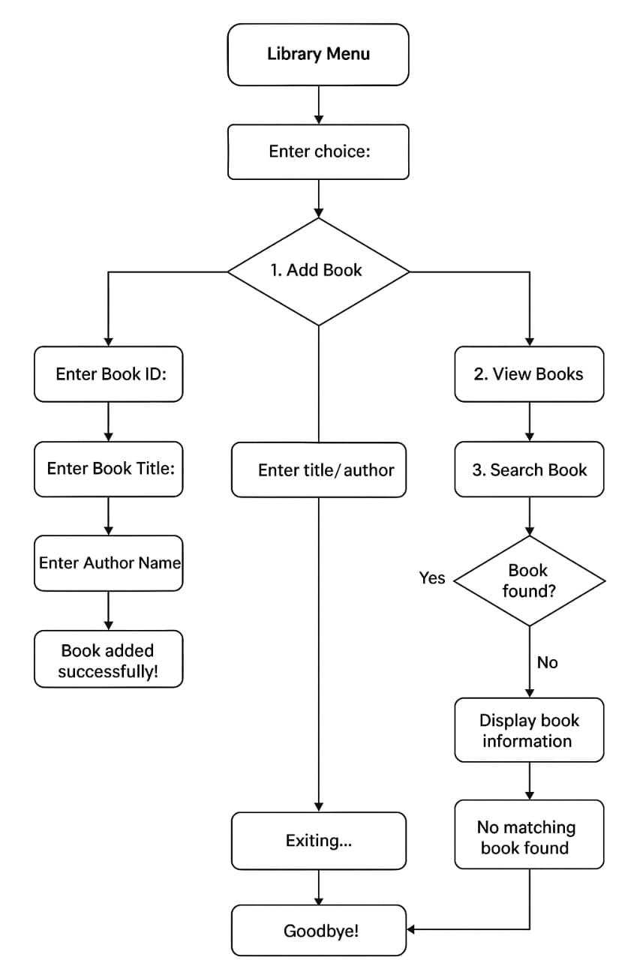
FUTURE SCOPE OF THE PROJECT
The Library Management System has strong potential for future development and expansion as technology and user needs evolve. While the current system streamlines basic library functions, there are several areas where it can be enhanced to offer more advanced features and broader capabilities.
- Integration with Cloud Services:
Future versions can migrate the database and application to the cloud, allowing remote access, data backup, and synchronization across multiple branches or institutions.
- Mobile Application Support:
Developing a mobile app version of the system will provide users with convenient access to library services such as book search, reservations, and notifications directly from their smartphones.
- RFID and Barcode Integration:
Implementing RFID or barcode scanning can automate the processes of book issue/return, improve inventory tracking, and reduce manual errors.
- AI-based Recommendations:
Artificial Intelligence can be integrated to provide personalized book recommendations to users based on their reading history and preferences, enhancing user engagement.
- Online Reading and Digital Library Access:
Adding features to support eBooks, audiobooks, and online reading within the system would expand its utility and make it a hybrid physical-digital library solution.
- Multi-language and Accessibility Support:
To serve a wider audience, future updates can include support for multiple languages and accessibility features for differently-abled users.
- Analytics and Data Visualization:
Advanced analytics dashboards can be introduced for administrators to track trends such as most borrowed books, peak usage times, and user behavior, enabling data-driven decisions.

Conclusion
With continuous advancements in technology and increasing digital demands, the Library Management System can evolve into a powerful, intelligent platform that not only manages physical resources but also enriches user interaction and learning experiences. Its flexibility and scalability make it suitable for long-term use and future upgrades in various library settings .

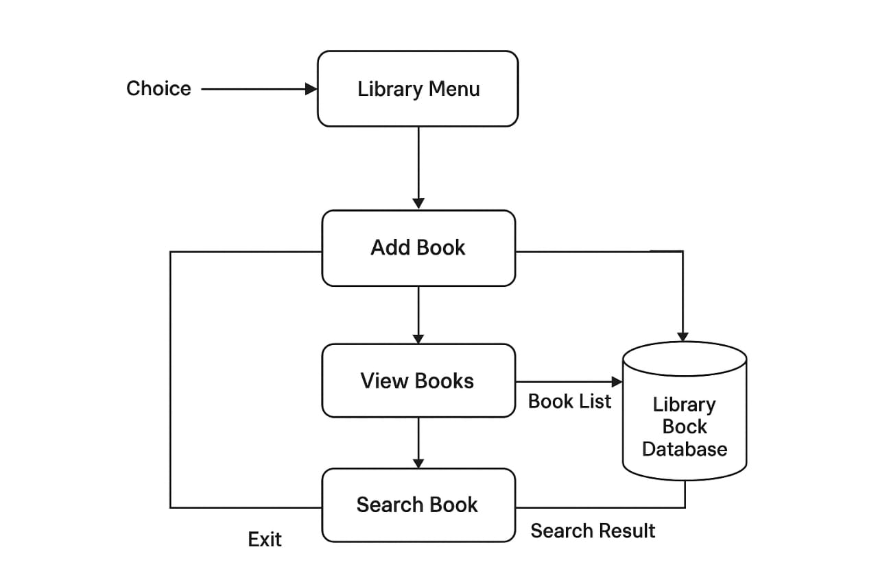
CODE:
#include <stdio.h>
#include <string.h>

struct Book {
int id;
char title[40];
char author[40];
};

void addBook() {
struct Book b;
FILE *fp = fopen("library.txt", "a");

printf("Enter Book ID: ");
scanf("%d", &b.id);

printf("Enter Book Title: ");
scanf(" %[^\n]s", b.title);

printf("Enter Author Name: ");
scanf(" %[^\n]s", b.author);

fprintf(fp, "%d|%s|%s\n", b.id, b.title, b.author);
fclose(fp);

printf("Book added successfully!\n\n");
}

void viewBooks() {
FILE *fp = fopen("library.txt", "r");
struct Book b;

if (fp == NULL) {
printf("No books found.\n\n");
return;
}

printf("\n--- Library Books ---\n");
while (fscanf(fp, "%d|%[^|]|%[^\n]\n", &b.id, b.title, b.author) != EOF) {
printf("ID: %d, Title: %s, Author: %s\n", b.id, b.title, b.author);
}
printf("\n");

fclose(fp);
}

void searchBook() {
FILE *fp = fopen("library.txt", "r");
struct Book b;
char key[40];
int found = 0;

if (fp == NULL) {
printf("No books found.\n\n");
return;
}

printf("Enter title or author to search: ");
scanf(" %[^\n]s", key);

while (fscanf(fp, "%d|%[^|]|%[^\n]\n", &b.id, b.title, b.author) != EOF) {
if (strstr(b.title, key) || strstr(b.author, key)) {
printf("Found → ID: %d, Title: %s, Author: %s\n", b.id, b.title, b.author);
found = 1;
}
}

if (!found) {
printf("No matching book found.\n");
}

printf("\n");
fclose(fp);
}

int main() {
int choice;

while (1) {
printf("===== Library Menu =====\n");
printf("1. Add Book\n");
printf("2. View Books\n");
printf("3. Search Book\n");
printf("4. Exit\n");
printf("========================\n");
printf("Enter choice: ");
scanf("%d", &choice);

switch (choice) {
case 1: addBook(); break;
case 2: viewBooks(); break;
case 3: searchBook(); break;
case 4:
printf("Exiting... Goodbye!\n");
return 0;
default:
printf("Invalid choice! Try again.\n\n");
}
}
}
PROFILE OF TWO IT COMPANY

1.TCS (Tata Consultancy Services)
1. Basic Info

Founded: 1968

HQ: Mumbai

Large IT service and consulting company.

- Services

Software development

Cloud, AI, Data analytics

IT consulting

  - Technologies

Java, Python, .NET

Cloud (AWS, Azure)

AI, Big Data

  - Career & Work Culture

Stable jobs

Good training

Work–life balance

  - Placement Process

Eligibility: 60%+

Rounds: Aptitude → Technical → HR

  - Contact

Email: corporate.office@tcs.com

LinkedIn: TCS official

- Infosys

  - Basic Info

Founded: 1981

HQ: Bengaluru

Global IT & consulting company.

  - Services

Software services

Cloud, AI, Automation

Business consulting

  - Technologies

Java, Python

Cloud (AWS, Azure)

Data analytics

  - Career & Work Culture

Good training (Mysore campus)

Friendly work environment

  - Placement Process

Eligibility: 60%+

Rounds: Aptitude → Technical → HR

  - Contact

Email: contact@infosys.com

LinkedIn: Infosys official

REFERENCES

- WWW.WIKEPIDIA.COM
- https://www.geeksforgeeks.org/
- Leetcode.com
- And other resources.

